Linux Lab 7 - Parsing Text
Linux system admins worked from text-only terminals for years, so they developed some great utilities, tools, and methods for parsing text.

Read
“The Linux Command Line,” chapter 6, Redirection, pp 49 -58.
Some points about the reading:
The OS has standard locations for sending and receiving output, the keyboard, and the display.
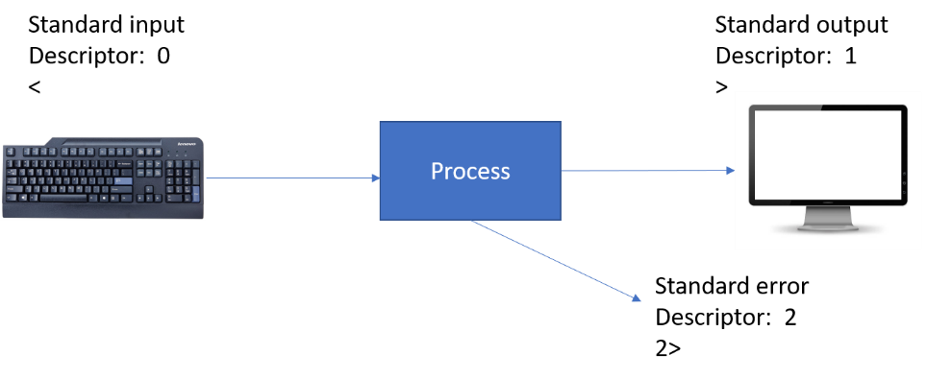
These inputs and outputs may be redirected, so they go somewhere else; often it is the file system. The command from page 50 of the text
$ ls -l /usr/bin > ls-output.txt
redirects the output of the ls command from the display to a text file. The “>” character is the one that specifies redirection.
A pipe (or pipeline) makes the output of one command be the input of the next command. In a previous lab, the ps aux file gave us a lot of output and we were only looking for the line that contained “xlogo.” So, we piped the output of the ps command into grep to search for lines containing xlogo.
$ ps aux | grep xlogo
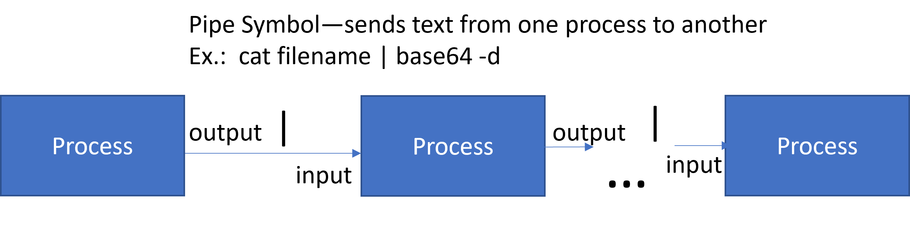

A Few Linux Text Utilities
We will use a file of data extracted from a Windows event log to practice using the Linux commands grep, cut, sort, and unique. This just scratches the surface of what is available, as there are entire books written on Regular Expressions (grep is named after them), sed, AWK, and other tools.
For this exercise we will pretend that Evil Hacker has broken into a Windows machine and stolen sensitive data. Fortunately, auditing for file access was active on the victim computer so we have a record of what the attacker did. Our job is to tell the organization what files the attacker accessed.
Part of the data in the file we have, File_Access.txt, includes the names of files that the attacker accessed. However, there is a lot of other data in this file, and the files accessed are listed multiple times. Our job is to extract just the file names. We could do this manually, but it would take a lot of time to carefully examine the entire 0.8 MB+ file. Imagine the problem we would have if the file were over 6 TB long! Enterprise log files can easily get that long. We can do our job quickly and easily with just a few commands.

Download the text file
Download File_Access.txt from Canvas. If you’ve downloaded the file from your Windows Host (the OS you are running VMware Player on), you’ll need to copy it to your Linux VM. If VMware Tools or open-vm-tools, is running on your VM, you’ll be able to copy and paste the file directly into your home directory as shown below.
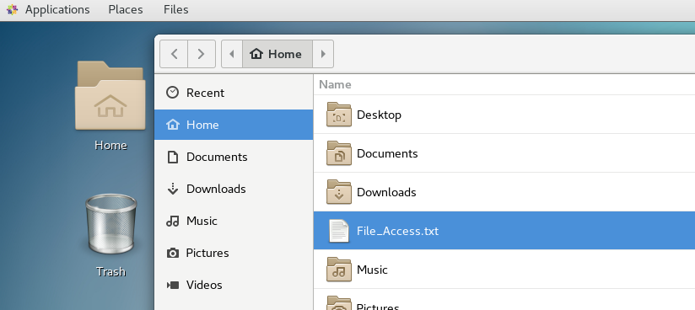
If the tools are not working, a work-around would be to open Canvas from the Firefox browser on your Linux VM. If you do that, move the file from your Downloads directory up to your home ( ~, or /home/username ) directory.
From here on, everything we do will be in the terminal. (We could be cool and download the file from the command line, but it would be a lot of work to log in to Canvas and find the file we need.) Open a terminal and make sure you have File_Access.txt in your home directory.

john@ubuntu:~$ ls -l File_Access.txt

-rw------- 1 john john 1728094 Jun 26 16:01 File_Access.txt

Step 1 Find the information and remove unneeded stuff

Take a look at the file
First, we must do some reconnaissance. We need to examine the file to find a key phrase or character string we can search for so that we can extract the file names. The senior member of the incident response team has told us that file access on Windows systems is often recorded with Event ID 4663.
Open the file using less.
[john@john ~]$ less File_Access.txt
There is an easy to use search feature in less; type a forward slash (on the question mark key),enter the search term, and press return. In our case we are looking for 4663, which is the Windows Event ID for an attempt to access a file or object.
Event[2914]:
Log Name: Security
Source: Microsoft-Windows-Security-Auditing
Date: 2020-06-26T13:43:55.525
Event ID: 4663
Task: File System
Level: Information
Opcode: Info
Keyword: Audit Success
User: N/A
User Name: N/A
Computer: DESKTOP-UR71QBS
Description:
An attempt was made to access an object.

Subject:
Security ID: S-1-5-21-999993552-654098596-4043940906-1002
Account Name: evilhacker
Account Domain: DESKTOP-UR71QBS
Logon ID: 0x4E7A7

Object:
Object Server: Security
Object Type: File
Object Name: C:\SharedFiles\games\approvedgames.txt
Handle ID: 0x2da8
Resource Attributes: S:AI

Process Information:
Process ID: 0x4
Process Name:

Access Request Information:
Accesses: READ_CONTROL

Access Mask: 0x20000
It looks like all of the file names are preceded by “Object Name:”. We can try that as a key phrase to search for.

Extract lines containing our key phrase
In its most basic mode, grep extracts any line that contains our search term. Use “grep --help” to see the format that grep uses. For our use, you should find this command works well enough.
[john@john ~]$ grep "Object Name:" File_Access.txt

Whoa! Lots of text scrolls off the top of the screen. Pipe the results from grep into less so we have time to look at it.
[john@john ~]$ grep "Object Name:" File_Access.txt | less
Object Name: -
Object Name: -
Object Name: -
Object Name: -
Object Name: C:\SharedFiles\games\approvedgames.txt
Object Name: C:\SharedFiles\games\approvedgames.txt
Object Name: C:\SharedFiles\games
Object Name: C:\SharedFiles\CorporatePlans\productupgrades.xlsx
Object Name: C:\SharedFiles\CorporatePlans\productupgrades.xlsx
Object Name: C:\SharedFiles\CorporatePlans\productupgrades.xlsx
Object Name: C:\SharedFiles\CorporatePlans\productupgrades.xlsx
<snip>

If you are stuck in less, type ‘q’ to get out of it.
Save the output from the last command to a file using redirection.
[john@john ~]$ grep "Object Name:" File_Access.txt > file1

Cut out unneeded columns
The cut command allows us to select columns of data, just as we would if the data were in a spreadsheet. In our case, the data we want is in the last column. We want to get the last column by itself so we can work on it.
Enter “cut --help” to see how the cut command works. The options we can use here are, -d [delimiter], and -f [field number, staring at 1.] The delimiter is the character that separates the columns. In our case, it could be a space or a tab, or possibly a colon. Note: if you don’t specify a delimiter, cut uses a tab. Also note that you can cut multiple columns (-f 2,3 grabs columns 2 and 3.) We only need the last column right now.
It is often difficult to tell spaces and tabs apart in printed output. You need to know where the spaces and tabs are in your output if you are to choose your delimiter well. One way to do this is to use
cat -A file1 | less
If you do that, tabs will show up as ^I and line feeds (Linux end of line) will show up as ^M. (Note: the carriage return that Windows uses will be ^R.)
^IObject Name:^I-^M$
^IObject Name:^I-^M$
^IObject Name:^I^IC:\SharedFiles\games\approvedgames.txt^M$
^IObject Name:^I^IC:\SharedFiles\games\approvedgames.txt^M$
^IObject Name:^I^IC:\SharedFiles\games^M$
^IObject Name:^I^IC:\SharedFiles\CorporatePlans\productupgrades.xlsx^M$
^IObject Name:^I^IC:\SharedFiles\CorporatePlans\productupgrades.xlsx^M$
In human-speak, a line would look like this
<empty field><TAB>Object Name:<TAB><empty field><TAB>C:\SharedFiles\games\approvedgames.txt<end of line>

Now you can see that you should probably use tab as your delimiter, since the file name you want always has a tab (^I) just before it. Again, to use tab as a delimiter, just leave the -d option out. Your command should look something like this, except you need to determine what field number to use. If you get no output, just experiment with the field number.
cut -f {field number goes here} file1

Another way to think about this is as a spreadsheet. If you use tabs to mark where columns start and stop, our data might look like this in a spreadsheet. The field number that goes into the cut statement is the number of the column in our spreadsheet, starting at 1
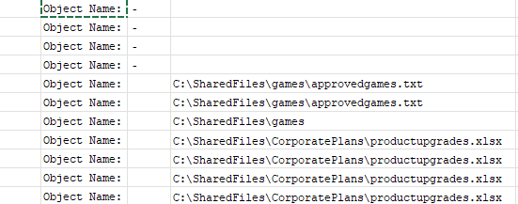

If all else fails, guess! When there are lots of columns, I often lose count. It will try a number in cut and see what happens. If I don’t get the data I want, I try again. In this case try 2 for the field number.
cut -f 2 file1 | less
It won’t be correct, but it will help you determine what the correct number is.

Pipe the output into less so you can scroll through it if you want to. If you are successful, the top of the output will look like this:
{some blank lines}
C:\SharedFiles\games\approvedgames.txt
C:\SharedFiles\games\approvedgames.txt
C:\SharedFiles\games
C:\SharedFiles\CorporatePlans\productupgrades.xlsx
C:\SharedFiles\CorporatePlans\productupgrades.xlsx
Once you have what you want, redirect the output into file2.
cut -f {field number goes here} file1 > file2

Step 2 Organize the information

One file, one entry
The data is full of duplicates, and we would like to remove them. The uniq command does that well, but it only works on data that has been sorted. Therefore, we use the sort command first.
[john@john ~]$ sort file2 | less

Here is sample output, scrolled down so it shows something other than “\”.

{some blank lines}
C:\SharedFiles
C:\SharedFiles\Accounting
C:\SharedFiles\Accounting
C:\SharedFiles\Accounting\CEOobjectives.docx
C:\SharedFiles\Accounting\CEOobjectives.docx
C:\SharedFiles\Accounting\CEOobjectives.docx
C:\SharedFiles\Accounting\DisciplineRecords.docx

We can pipe the sorted output into the uniq command
[john@john ~]$ sort file2 | uniq | less

{some blank lines}
C:\SharedFiles
C:\SharedFiles\Accounting
C:\SharedFiles\Accounting\CEOobjectives.docx
C:\SharedFiles\Accounting\DisciplineRecords.docx
C:\SharedFiles\Accounting\EmployeeSalaries.xlsx

Voila! We could keep going to clean up the list some more, but this demonstrates the point. Note: we could have used sort -u instead of piping the results of sort into uniq.

Step 3 Putting it all together
A true Linux sysadmin does not usually create intermediate files (file1 and file2) like we did. Instead, they will put it in one command like this:
[john@john ~]$ grep "Object Name:" File_Access.txt | cut -f 4 | sort | uniq > answer.txt

Note that the command redirects the output to a file called answer.txt. Hand in that file using Canvas to show you did this lab.

A good sysadmin may test a new command one step at a time, however, piping the results of each step into less for easier troubleshooting. For example, a sysadmin may follow this sequence:

grep "Object Name:" File_Access.txt | less (looks at data, and fixes errors if we grabbed the wrong thing.)
grep "Object Name:" File_Access.txt | cut -f 4 | less (examines data, fixes errors if we got the wrong column)

grep "Object Name:" File_Access.txt | cut -f 4 | sort | uniq | less (examines data, fixes errors)

grep "Object Name:" File_Access.txt | cut -f 4 | sort | uniq > answer.txt

Hand in
Submit a copy of your answer file.

